Technical & Financial Proposal
Development of Radiology Queue Management System (RQMS)
Submitted by: Digi Drive Technology (DDT)

1. Executive Summary
Digi Drive Technology (DDT) is pleased to submit this proposal for the design, development, implementation, training, and support of a Radiology Queue Management System (RQMS) for CMH Dhaka.
The proposed system will digitize patient queue management from reception to radiography rooms, enabling faster patient flow, reduced waiting time, improved service quality, and efficient workflow management.
The solution will provide a centralized queue management platform with patient registration, radiographer dashboards, automated voice announcements, administrative controls, and comprehensive reporting.

2. Objectives
The proposed system aims to:
- Digitize patient registration and queue management.
- Eliminate manual patient calling.
- Reduce patient waiting time.
- Improve workflow efficiency.
- Provide real-time queue monitoring.
- Automate Bangla and English voice announcements.
- Generate operational reports for management.
- Maintain secure user authentication and audit logs.

3. Scope of Work
DDT will design, develop, deploy, test, and commission the complete software solution.
The project includes:
Reception Module
- Patient Registration
- Automatic/Manual Queue Number Generation
- Queue Assignment
- Search Patient
- Edit Patient Information
- Cancel Queue
- Queue Status Monitoring
Radiographer Dashboard (4 Users)
Each radiographer will have:
- Secure Login
- Today's Queue
- Call Next Patient
- Recall Patient
- Skip Patient
- Complete Examination
- View Patient Details
- Queue Status
- Waiting Count
Audio Announcement System
The system will automatically announce patient calls through the hospital speaker system.
Supported Languages:
- Bangla
- English
Example Announcement:
"টোকেন নম্বর R-023, মোঃ করিম, অনুগ্রহ করে এক্স-রে রুম ২-এ আসুন।"
or
"Token Number R-023, Mr. Karim, please proceed to X-Ray Room 2."
Features:
- Automatic announcement
- Simultaneous playback across all waiting room speakers
- Adjustable announcement volume
- Voice language selection
- Repeat announcement option
Administration Module
- User Management
- Radiography Room Management
- Queue Configuration
- Voice Configuration
- System Settings
- Queue Reset
- Activity Logs
- Backup & Restore
Reports
- Daily Patient Report
- User-wise Patient Report
- Waiting Time Analysis
- Completed Patients
- Skipped Patients
- Recall History
- Queue History
- Call History
- Date-wise Statistics
Security Features
- Role-based User Access
- Password Encryption
- Audit Trail
- Automatic Logout
- Database Backup

4. Proposed Technology
- Backend: Python 3.11+ with FastAPI REST API
- Frontend: Angular 19 responsive web application
- Database: PostgreSQL (production) with structured backup and restore
- Real-time Communication: Secure WebSocket events for live queue and call updates
- Voice Engine: Pre-generated and cached Bangla & English announcement audio
- Deployment: Hospital Local Area Network (LAN), with optional secure remote administration
- Operating System: Linux or Windows Server; dedicated Linux audio receiver
4.1 System Architecture & Technical Design
The solution will use a centralized client-server architecture designed for reliable operation within the hospital network.
- Central application server hosts the API, database, authentication, reporting, and real-time event services.
- Reception and radiographer consoles use role-based responsive web interfaces on authorized LAN devices.
- Queue actions are delivered immediately to dashboards and waiting-room endpoints through WebSocket events.
- A dedicated browser-free Linux receiver service starts automatically, reconnects after interruption, queues announcements, and prevents overlapping playback.
- The receiver connects by USB audio/line-out cable to the hospital PA amplifier; no screen or user device is required.
- Announcement audio is generated centrally, cached for consistent pronunciation, and played only in the assigned audio zone.
- Daily automated database backup, audit logging, health monitoring, and controlled recovery procedures are included.
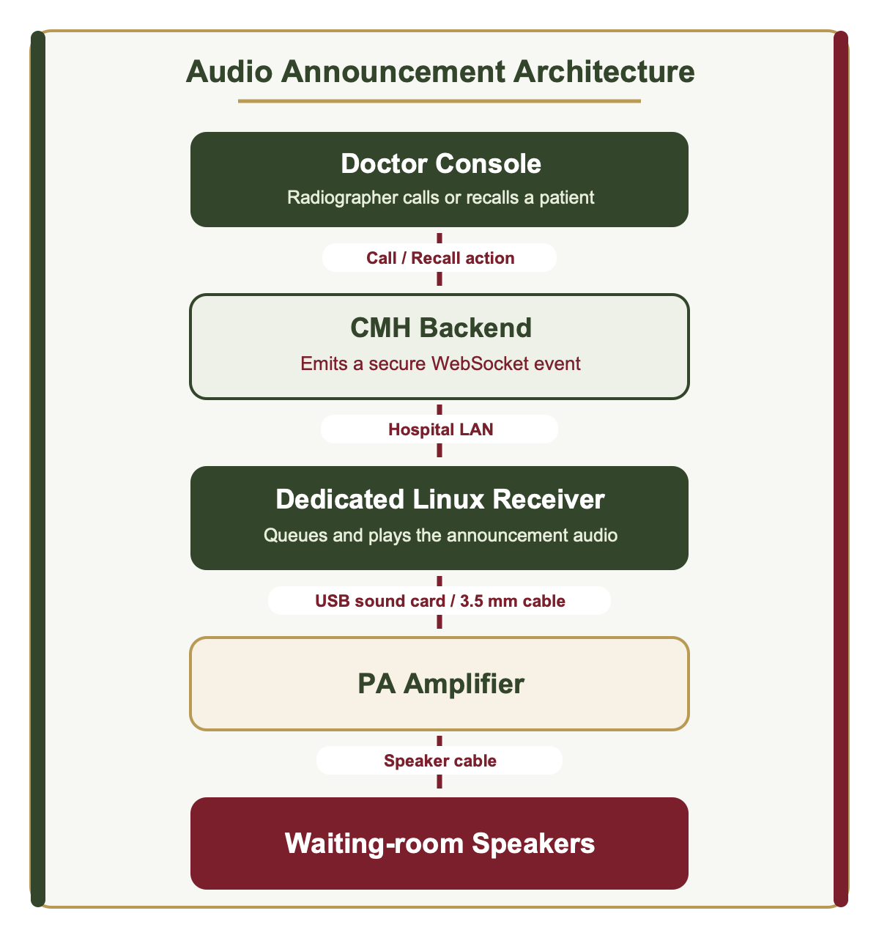

5. Deliverables
DDT will provide:
- Fully Functional Queue Management Software
- Database Design
- Installation & Configuration
- User Manual
- Administrator Manual
- Training for Users
- Source Code (if included in the contract)
- Technical Documentation
- One-Year Warranty Support

6. Implementation Schedule
Phase — Duration
- Requirement Study & System Design — 1 Week
- Software Development — 5 Weeks
- Internal Testing — 1 Week
- User Acceptance Testing (UAT) — 1 Week
- Installation & Training — 1 Week
Total Project Duration: 9 Weeks

7. Financial Proposal
Description — Amount (BDT)
- Software Architecture, UI & Application Development — 170,000
- Audio Announcement Integration — 35,000
- Database Design & Configuration — 15,000
- User Management & Security — 15,000
- Reports, Analytics & Audit Trail — 20,000
- Testing, UAT, Deployment & Commissioning — 25,000
- Training, Manuals & Technical Documentation — 20,000

Total Project Software Cost — ৳300,000
Note:
- VAT and applicable taxes are excluded unless otherwise specified.
- Hardware (PCs, speakers, amplifiers, networking equipment, etc.) is not included in this proposal.
- Third-party software licenses, if required, will be quoted separately.

8. Warranty & Support
- 12 Months Free Warranty
- Bug Fixes
- Technical Support during office hours
- Remote Assistance
- Minor Software Updates
Annual Maintenance Contract (AMC) after warranty:
12% of the software value per year

9. Payment Terms
Milestone — Payment
- Purchase Order / Work Order — 30%
- Completion of Development — 40%
- Successful UAT — 20%
- Final Deployment & Acceptance — 10%

10. Assumptions
- The hospital will provide the required PCs, LAN connectivity, speakers, and related hardware.
- One central server or designated computer will host the application, database, and real-time services.
- Voice announcements will use a dedicated receiver connected by cable to the existing hospital amplifier/PA infrastructure.
- Any future integration with Hospital Information System (HIS), Radiology Information System (RIS), or PACS is outside the current scope and may be proposed separately.

11. Why Digi Drive Technology
- Experienced in Government & Healthcare ICT Solutions
- Skilled Software Development Team
- Strong After-Sales Support
- Customized Solutions
- Secure and Scalable Architecture
- Competitive Pricing
- Timely Project Delivery

12. Validity
This proposal shall remain valid for 30 days from the date of submission.

Thank You
We appreciate the opportunity to submit this proposal and look forward to partnering with CMH Dhaka in implementing an efficient and reliable Radiology Queue Management System.
Submitted by
DigiDrive Technology (DDT)
Empowering Digital Transformation

